**Method :**

A Java method is a collection of statements that are grouped together to perform an operation.

public static int methodName(int a, int b)

{

// body

}

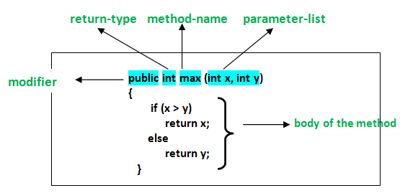

Class contains multiple methods.

We can call one method in another method without using an object iff both methods belongs to same class. Example is in eclipse

SO, if want to call one method from another method, then directly give a call (without using an object.) IT HAPPENS ONLY IN SAME CLASS